1. **Use Minitab to obtain the mean, median, standard deviation, and five-number summary for the women and men individually.**

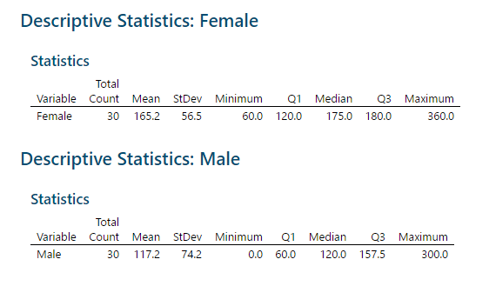

1. **Use Minitab to get a side-by-side boxplot of the men and women.**

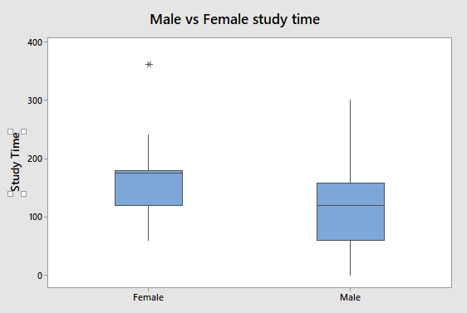

1. **Does it appear that women study more than men (at least based on this self reported data)? Justify your answer using the info from parts a and b.**The five-number summary seems to support this statement, at least based on the mean, min, and max, given that all of the female numbers are higher than the male numbers. However, this is hard to visualize. The side-by-side boxplot vividly shows that this looks to be the case, considering the majority of women in Q1 study around the same as men below the average but not in Q1. In general the box of the women is higher on the chart than the box for the men.

**2)**

* 1. **Use Minitab to obtain the following: stemplot, histogram, boxplot, mean, median, standard deviation, and five-number summary for the data in Calories.**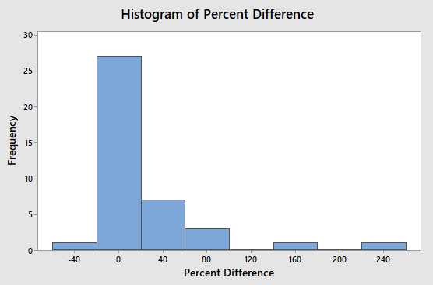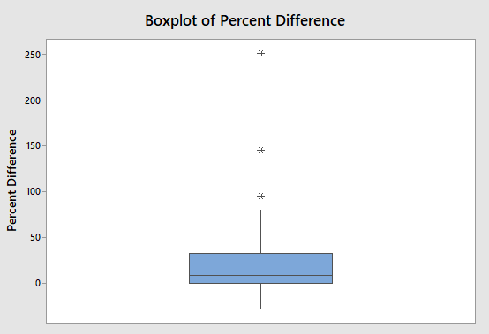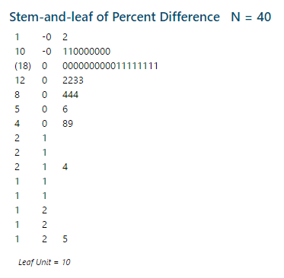
  2. **Discuss the 5 aspects of the overall pattern (as discussed in class) of the data for the Calories.**
  3. **What can you now tell me about these "diet" foods (using the results you got in parts a and b? I am looking for something specific here you should pick up on from what you’ve seen in parts a) and b). Think about what the data values actual represent (for example, what does a positive or negative data value mean here).**